* flowchart

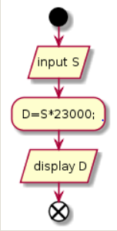

* pseudo-code

@startuml

start

:input S/

-D=S\*23000;

: display D/

End

@enduml